 | 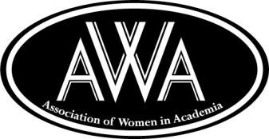 | Association of Women in Academia  Student Scholarship Fundraiser 2017
 | Houston Community College  3100 Main, Houston, Texas 77002 | Friday, April 21, 2017  6:00 p.m.-9:00 p.m. | Dinner, Fashion Show & Silent Auction  Southeast Campus Auditorium
SILENT AUCTION DONOR FORM
YES, I want to help the AWA raise funds for student scholarships!

*Required field
^{*NAME OF BUSINESS/DONOR} |  | ^{*CONTACT PERSON/POSITION}
*Name as you would like it to appear on poster and website: |  | I consent to be recognized on the AWA website.  X
^{*MAILING ADDRESS} |  | ^{*CITY} ^{*STATE} ^{*ZIP:}
^{*TELEPHONE} |  | ^{FAX}
^{*E-MAIL} |  | ^{WEB PAGE}

*Name and description of item or service being donated (Note: List 2 0r 3 details to assist in writing the display description):
INCLUDE ANY LIMITATIONS OR SPECIAL INSTRUCTIONS.

Item:  Monetary Donation $  Enclosed  Will be delivered on (date) at  (Location) .  Pickup on (date) at  (Location) ___________________________ | Gift Certificate:  AWA has my permission to make a certificate for this item.  Valid until (date) ____________________________  **Include appropriate marketing materials for display with bid sheet on auction day (menus, brochures, photographs, props)

^{*Approximate retail value} | Expiration Date
^{Signature of Donor}  X | ^{Date}
Donor: Please fax this form to (713) 718-7702 or email to mail to: awa@hccs.edu
Shanetta Burke ( Silent Auction Committee Chair ) shanetta.burke@hccs.edu April 7, 2017

